Instructions for authors (Style ‘Title’ used for this)
First Author, Second Author, Third Author (Style: ‘Author’)
An abstract of between 200 and 250 words in 12 pt Times New Roman, italics and justified both left and right. The abstract should contain one or two sentences reflecting the background of your investigation, a sentence with the purpose of the paper, something about the research method used, several sentences giving a clear and precise idea of your main results, followed by one or two sentences mirroring your conclusions and the contributions to one of more of the Sustainable Development Goals. You may need to modify your original abstract when you submit the full paper so as to ensure that the abstract as printed will be a true reflection of your paper. (Style ‘Abstract’ used for this).
KEYWORDS: maximum five keywords (Style: ‘Keywords’)
Introduction (Style ‘Section heading’)
This set of instructions for authors is applies for the 11th Nordic Conference on Construction Economics and Organization. If you do not apply this template directly when writing your paper, the text of these instructions will explain to you how to format your document manually (Style ‘Normal’ used for this).
General requirements (Style ‘Subsection heading’)
The length of your conference paper is maximized at 12 pages. The paper may be rejected if it exceeds this limit. Set margins at 2 cm up, down, left and right. Do not insert page numbers. Use 12 pt, Justified ‘Times New Roman’ for the normal text.
Use hard return after each paragraph (no indentations). Line spacing in paragraphs is 1 and alignment is left and right justified.
Headings (Style ‘Subsection heading’)
Title heading of the paper is centred. Use 18 pt, Bold Times New Roman for the title of the paper.
Headings within the paper are justified left only. ‘Section heading’ is 14 pt Bold Times New Roman aligned to the left. ‘Subsection heading’ is 12 pt Bold Times New Roman aligned to the left. ‘Sub-subsection headings’, if required, is 12 pt Bold and Italics ‘Times New Roman. Headings should be short and not numbered. All headings should be ended with a hard return.
Bold type for sub-subsection headings (Style ‘Sub-subsection heading’)
Bold type is used for the title and headings, but never in the main text. Italics can be used for a word or a few words in the main text and for inline quotations. No manually inserted permanent hyphens in the text, please. Avoid footnotes; if absolutely necessary, they should be numbered and placed at the foot of the page.
Use abbreviations and acronyms sparingly, and explain all of these immediately when they occur first in your paper. Only the most obvious can be left unresolved (‘UK’ is generally understood, but ‘NHS’ needs an explanation).
The title
The title should preferably be no longer than ten words. Long titles should be broken up with a subtitle, preceded by a colon (:). The title should provide a maximum of information. In particular, it should indicate somehow whether there is a survey or case study involved or not.
Authors and their affiliations
See the example above. There is a hard return after the last author’s name followed by the Abstract. Insert a footnote for each author detailing their affiliation.
Keywords
Please add up to five keywords. There is a hard return after the abstract and the keywords. This is followed by the first Section heading (introduction).
Tables and figures
Titles of tables and figures are to be placed below the object followed by a hard return. Any table or figure is preceded by 2 hard returns. Tables and figures should be centered. An example of a table is given here (See Table 1). First row in the table should be in bold.
Category | Area (sqm) | Response rate (%)
Housing | 230,000 | 58.5
Manufacturing | 410,400 | 87.4
Retail | 123,000 | 62.0
Table 1: Title of Table (Style ‘Table Heading’ used for this).
No table or figure may appear earlier in the text than the explicit reference to it does (e.g. ‘See Table 2.’). Never use the words ‘above’ or ‘below’ to refer to a table or a figure. Tables are numbered consecutively (Table 1, Table 2, …) and so are figures (Figure 1, Figure 2, …). There should be both vertical and horizontal lines in tables.
Figures should only be used where absolutely necessary. Graphs should be two dimensional and have no shadows. Colour should not be used, as the proceedings will be printed in black and white.

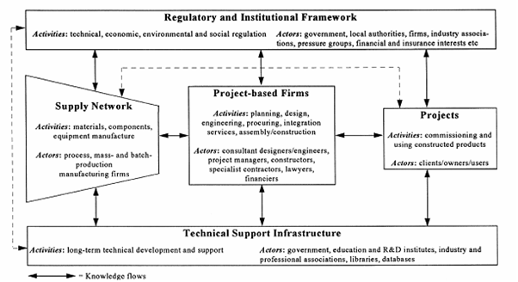
Figure 1: Construction business system (Style ‘Figure Heading’ used for this). Source: Gann & Salter (2000: 960).
Conclusions
This section should bring together the paper with the conclusions of the research. It should relate to the SDGs and discuss its contribution to a change in understanding and practices of construction economics and organisation. Future work flowing from the research may be mentioned.
Acknowledgements
Acknowledgements may be added after the conclusion but before references.
References
It is good to have source references for all statements that can be expected to raise doubts among readers and that do not follow from an empirical investigation reported in the paper itself. References to other publications must be complete and in APA style, exactly as the following examples.
Within the main text, references are either written as (Smith, 2003) or given as ‘Smith (2003) has found that […]’. If there are two authors, use ‘&’ between their surnames e.g. (Gann & Salter, 2000). Three or more authors are referred to as (Jones et al., 2002) or ‘[…] as Jones et al. (2002) claim […]’. If the reference is to a particular item please add a page reference (Brown, 2003: 231).
After the conclusions in your paper, there are the REFERENCES. Please check that all your references in the main text correspond to your final list of references. These are ordered alphabetically, with hard return after each reference. References are 12 pt. Times New Roman with 1 cm hanging indentation.
Use Style ‘References’ for this list. They should contain full bibliographical details and journal titles should not be abbreviated. For more than one publication by the same author(s) in the same year, use a, b, c etc. after the year of publication: 2001a, 2001b and so forth.
Books (monographs) must follow this pattern
Cheeseman, K. (2002). Waste minimisation – a practical guide. London: Chadwick House Publishing.
Articles in scientific journals
Seydel, A., Wilson, O. D. & Skitmore, R. M. (2002). Financial evaluation of waste management methods: a case study. Journal of Construction Research, 3(1), 167-179.
Gann, D. M. & Salter, A. J. (2000). Innovation in project-based service-enhanced firms: the construction of complex products and systems. Research Policy, 29, 955-972.

Department, University, Country, Email.
Department, University, Country, Email.
Department, University, Country, Email.

